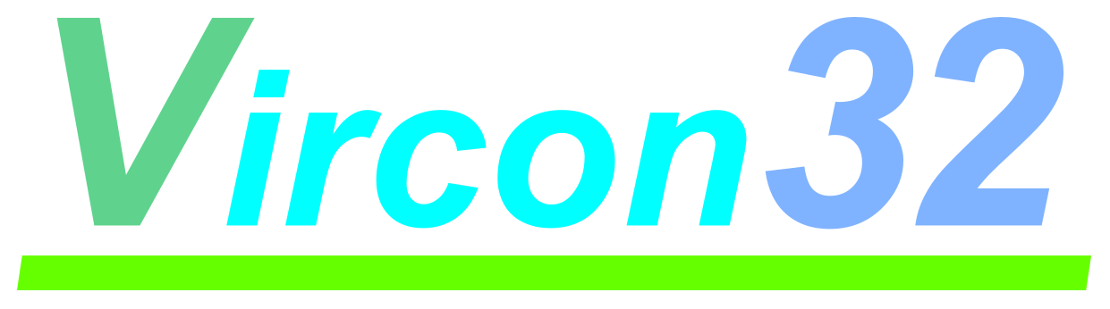

**32-BIT VIRTUAL CONSOLE**

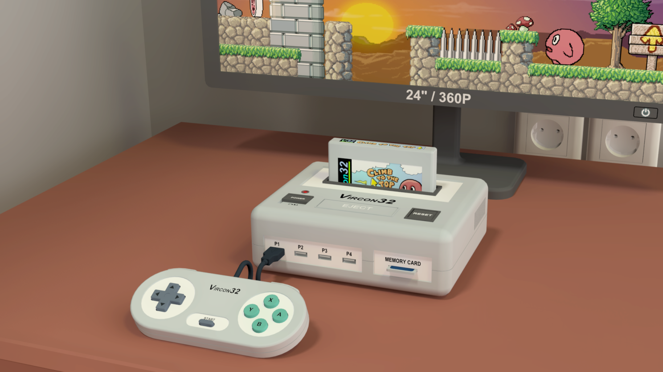

**System specification**

**Part 1: The Vircon32 system**

Document date 2023.01.08 Written by Carra

**What is this?**

This document is part number 1 of the Vircon32 system specification. This series of documents defines the Vircon32 system, and provides a full specification describing its features and behavior in detail.

The main goal of this specification is to define a standard for what a Vircon32 system is, and how a gaming system needs to be implemented in order to be considered compliant. Also, since Vircon32 is a virtual system, an important second goal of these documents is to provide anyone with the knowledge to create their own Vircon32 implementations.

**About Vircon32**

The Vircon32 project was created independently by Carra. The Vircon32 system and its associated materials (including documents, software, source code, art and any other related elements) are owned by the original author.

Vircon32 is a free, open source project in an effort to promote that anyone can play the console and create software for it. For more detailed information on this, read the license texts included in each of the available software.

**About this document**

This document is hereby provided under the Creative Commons Attribution 4.0 License (CC BY 4.0). You can read the full license text at the Creative Commons website:

<https://creativecommons.org/licenses/by/4.0/>

**Summary**

Part 1 of the specification first provides a general introduction to Vircon32. It defines the scope of a Vircon32 system, and provides basic knowledge of the elements that form it.

1 What is Vircon32? 3

2 Scope of the Vircon32 system 5

3 Overview of top-level devices 6

## 1 What is Vircon32?

Vircon32 is a virtual 32-bit gaming system. The name Vircon itself is an acronym for “virtual console”. What that means is that this is a console that could either be created physically or be emulated by other systems, like a computer.

This gaming system is made up from scratch: it’s not based on any other previously existing machine. So in essence this specification and the emulators/hardware that implement it ARE the console.

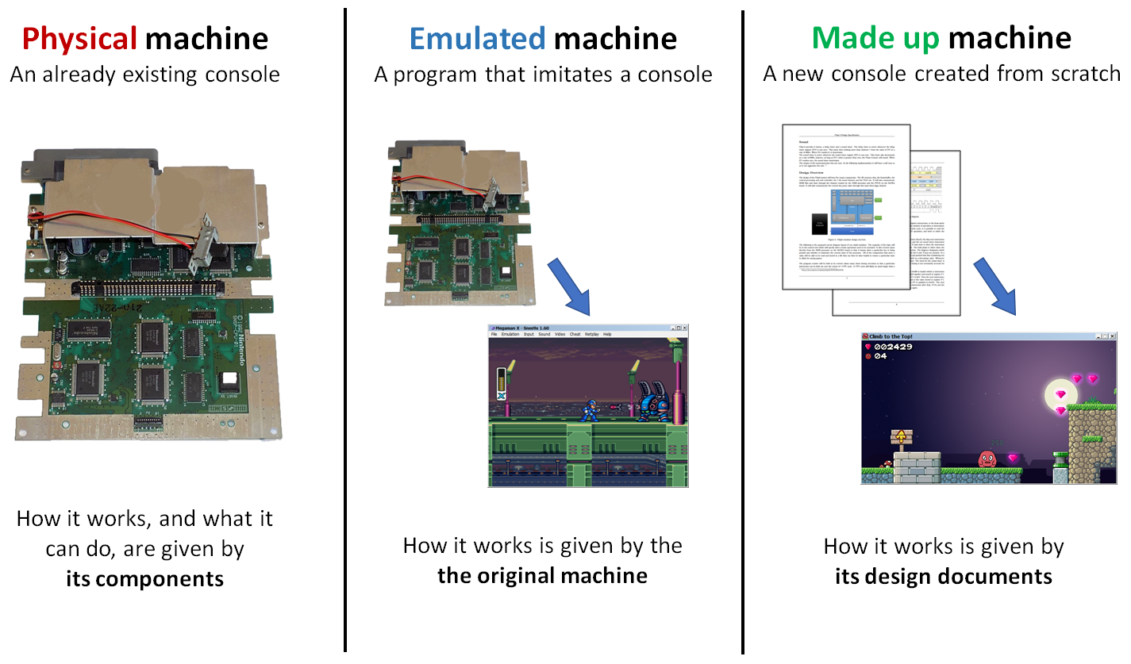

### 1.1 Why was this created?

In the last years there has been a surge of interest in retro consoles. Machines like the Sega Genesis or the NES are widely known and well emulated. Being closed systems and much simpler than current consoles, many people have been wanting to create their own games for them. Unfortunately it can be quite complex to program these old consoles. Even just playing them is often inconvenient on modern systems. No widescreen, PAL/NTSC differences, region locks, too low resolutions… to name a few.

Vircon32 was created to provide a well defined game retro-style console that solves these problems. Its features have been adapted to make it better suited to modern systems. And by simplifying the way it works, game creation has been made much easier and more intuitive. It can just draw images on screen, instead of using tiles or sprites. It can just play sound and music instead of using FM synthesis or programming a sound chip.

There have been other retro-inspired systems such as Pico-8 or TIC-80, but these systems seem to be aimed more at making experiments and technical demos rather than actual games. For this reason they were designed with some very impractical limitations. As an example, games for Pico-8 can only be 15 KB in size. Another important difference is that these systems they don’t work like retro consoles at all. They are essentially Lua scripting platforms, which makes a very different experience for a game maker.

### 1.2 Global design goals

Vircon32 has been designed with the main goal of being as simple as possible, while still providing enough features to allow for full-fledged games.

In this case, being simple covers multiple different goals:

* Simple for users to set up and play
* Simple for game creators to program and understand
* Simple for contributors to create development tools

The internals of Vircon32 have been modeled like a real machine: it has a processor, graphics and audio chips, controllers, buses… These components are simplified compared to a real machine, but their behavior is still clearly defined. This makes it much easier to create games, emulators and other tools when compared to classic consoles.

### 1.3 General capabilities

Vircon32 has been based on the 32-bit generation of home consoles (i.e. PlayStation, Nintendo 64 and Saturn). Its capabilities in general can be considered similar to these consoles. There is an important exception though: Vircon32 graphics capabilities are limited to 2D. Adding a 3D graphic system would introduce too much complexity for a simplified console such as this one.

Another significant difference is that Vircon32 graphics are widescreen and higher resolution. By using 360p, Vircon32’s display scales much better to current screens and also lets graphics not be so limited by the small resolution.

Other console features also mimic the mentioned consoles. Vircon32 games can have large storage capacity and save progress in separate memory cards. Also, something very important we take from that era is the very concept of a console at that moment. We are speaking about a game system thought for offline games. There is no external connectivity of any kind.

## 2 Scope of the Vircon32 system

The Vircon32 system as a whole is not very different from a classical 32-bit console setup: aside from the console we have up to 4 gamepads, a cartridge and optionally a memory card. The console outputs video and audio that we will treat separately, although a typical classic console would join these 2 outputs in a single cable to a TV display.

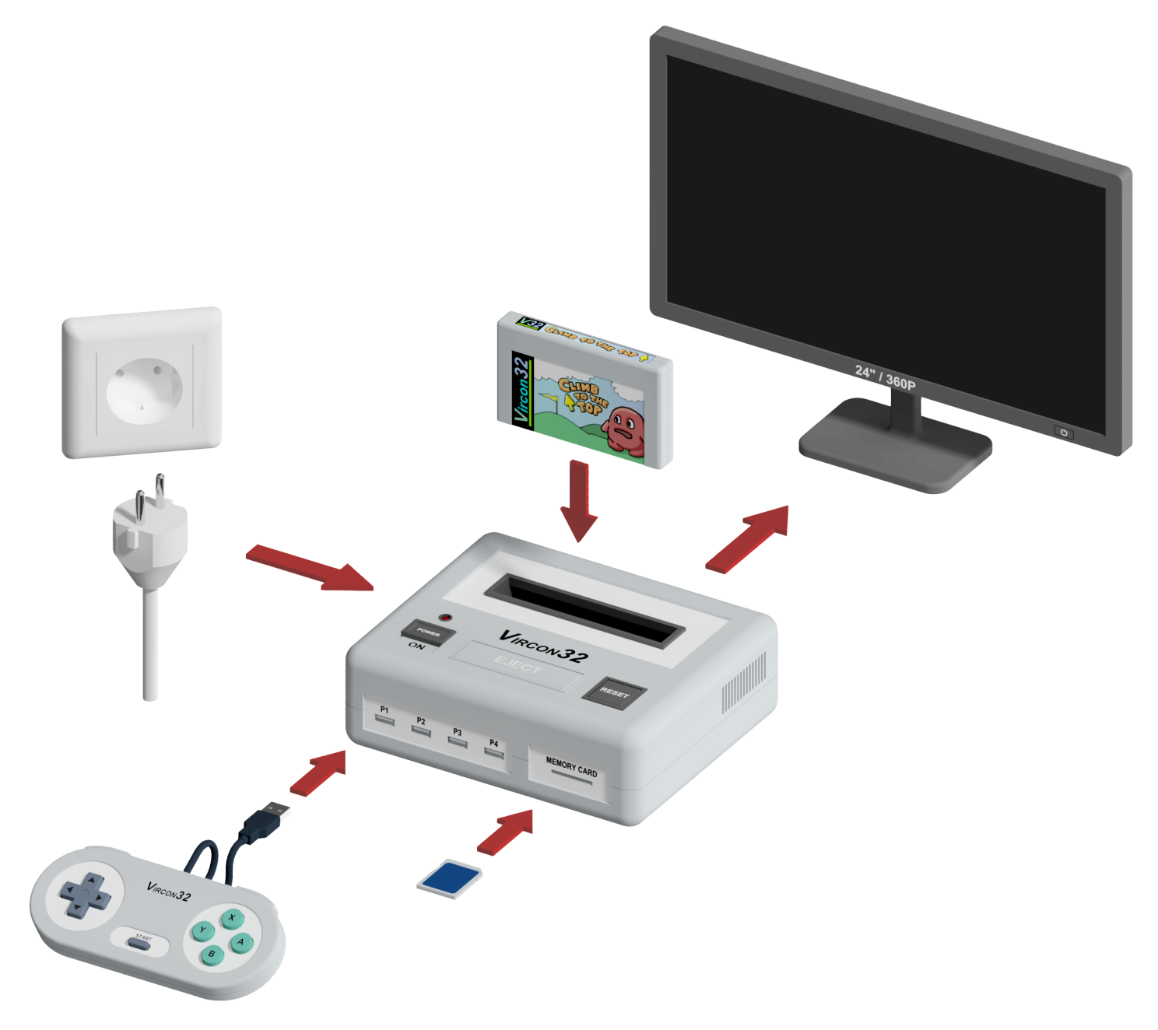

The Vircon32 standard covers the whole gaming system, and not just the console. Elements such as the screen or gamepads also influence the gaming experience, and need to be modeled so that implementations can take into account their features and behavior.

Modeling the key features of external elements in addition to the console itself makes the system better defined. For users, this results in a more consistent gaming experience across all compliant Vircon32 systems. For implementations creators, this extra information helps clear any doubts about how the console should interact with the devices connected to it.

## 3 Overview of top-level devices

We will now list each of the basic devices in a Vircon32 system, and give a brief introduction to them. All of these devices will be defined in detail in later documents.

Please note that the images included in this section are mere artistic recreations, meant just as a quick visual reference for better understanding. As stated in the introduction, Vircon32 is only designed as a virtual gaming system and there are no plans of creating a physical version of it.

### 3.1 Console

The console is the core component since it runs the games. Console operation is pretty standard: it can be turned on and off by using the power switch. When turned on, its functions can be restarted with the reset button. In addition to this, users can connect or remove devices from it.

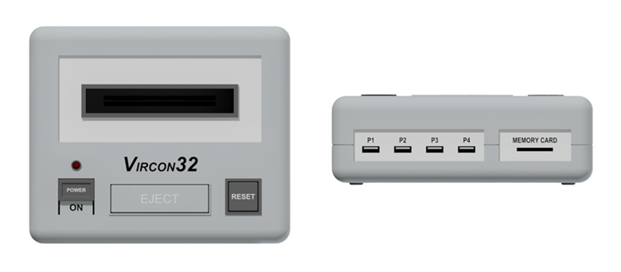

As for external connectivity we have the cartridge input, 4 gamepad ports, a slot for a memory card and output connectors for image and sound. The console does not feature expansion ports or any further external connection.

### 3.2 Gamepads

Vircon32 gamepads feature a d-pad, 4 front buttons, 2 shoulder buttons and a central button for Start. The layout of these elements is as seen in this image.

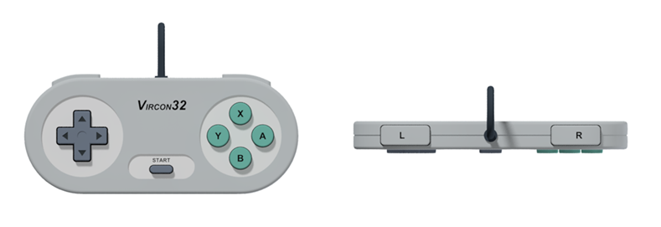

All controls in the gamepad are digital: they only distinguish between being pressed or not. The d-pad uses a tilting mechanism, so in each axis the 2 opposite directions can never be pressed at the same time.

### 3.3 Screen

Vircon32 screen has a resolution of 640x360 pixels at 16:9 aspect ratio, and it works at 60 frames per second. So, in terms of modern displays, it is a 360p resolution. The color depth that the screen can display is true color (RGB channels, with 8 bits per channel).

By using 360p resolution, Vircon32 image output can be adapted to the most common screens used today (720p, 1080p, 1440p, 4K) using integer scaling to prevent distortion of the image.

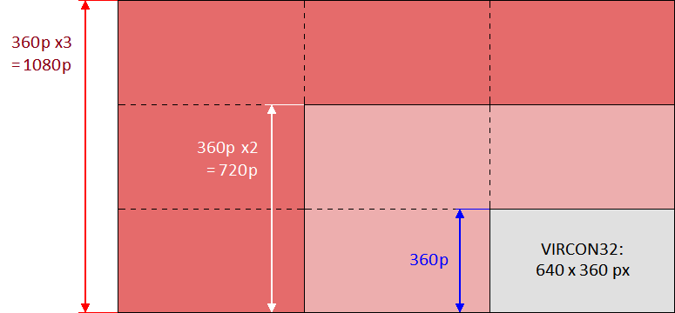

This resolution also meets a sensible balance: it is visibly higher than those of classic consoles (typically 320x240 or less). But it is still small enough so that games can be made using pixel art without getting too costly.

### 3.4 Speakers

Vircon32 uses a standard set of 2.0 speakers, to achieve stereo sound. This means there are 2 independent sound sources: one for left samples and another for right samples.

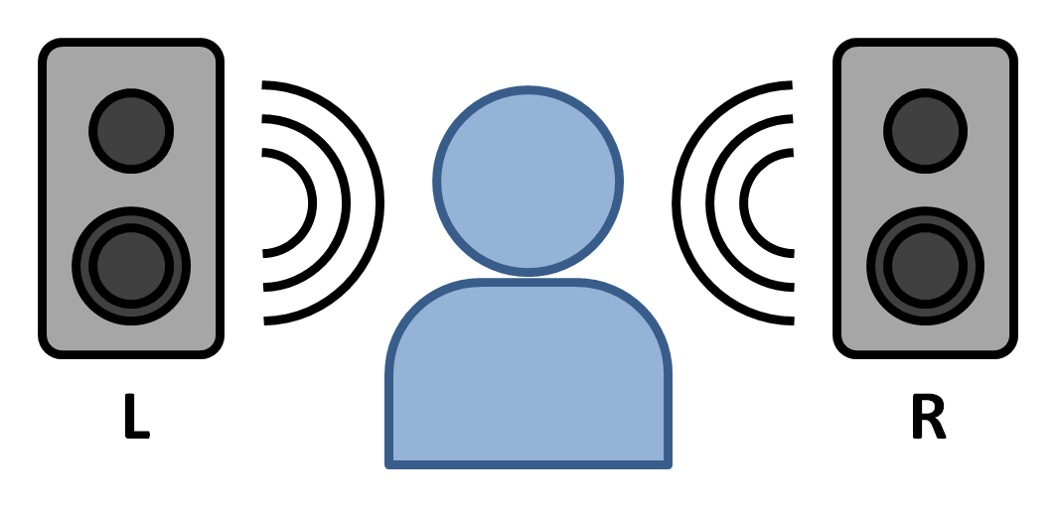

Sound is produced at a rate of 44100Hz, and samples have 16-bit precision. Or, in other words, it is CD quality.

### 3.5 Cartridges

Vircon32 cartridges contain 3 independent read-only memories (ROMs): Program, video and audio. All 3 are uncompressed for simplicity and immediate access. A cartridge can hold up to 2.5 GB in total.

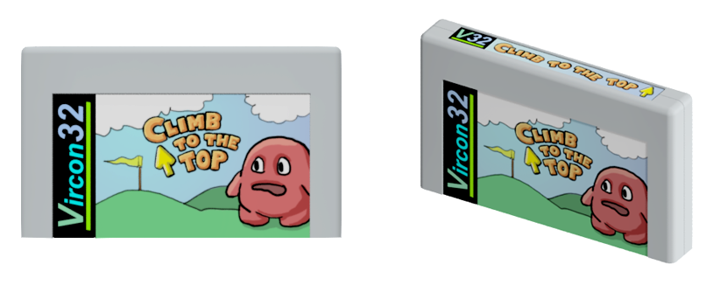

### 3.6 Memory cards

Since cartridges are read-only, the console allows the use of memory cards as a small permanent storage. With this we can support the creation of longer or more complex games, in which the game can be saved. These memory cards have a capacity of 1 MB.

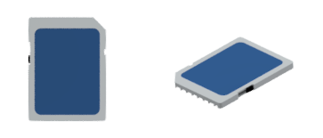

*( End of part 1 )*